\

*Green University of Bangladesh*

#### Department of Computer Science and Engineering (CSE) Semester: (Fall, Year: 2024), B.Sc. in CSE (Day)

**Application of Book Store**

#### Course Title : Microprocessors and Microcontrollers Lab Course Code : CSE-304

#### Section : 222_D13

### Students Details

|  |  |
| --- | --- |
| **Name** | **ID** |
| Md. Moshiur Rahman | 221902324 |

#### Submission Date: 09-12-2024

#### Course Teacher’s Name: Md. Jahid Tanvir

### [For teachers use only: Don’t write anything inside this box]

**Date:**

**Comments:**

**Signature:**

**Marks:**

**Lab Project Status**

**Contents**

1. Introduction 3
   1. Overview . . . . . . . . . . . . . . . . . . . . . . . . . . . . . . . . . . . . . 3
   2. Motivation . . . . . . . . . . . . . . . . . . . . . . . . . . . . . . . . . . . . . 3
   3. Problem Definition . . . . . . . . . . . . . . . . . . . . . . . . . . . . . . . . 3
      1. Problem Statement . . . . . . . . . . . . . . . . . . . . . . . . . . . . 3
      2. Complex Engineering Problem . . . . . . . . . . . . . . . . . . . . . . 4
   4. Design Goals/Objectives . . . . . . . . . . . . . . . . . . . . . . . . . . . . . 4
   5. Application . . . . . . . . . . . . . . . . . . . . . . . . . . . . . . . . . . . . 4
2. Design/Development/Implementation of the Project 5
   1. Introduction . . . . . . . . . . . . . . . . . . . . . . . . . . . . . . . . . . . . 5
   2. Project Details . . . . . . . . . . . . . . . . . . . . . . . . . . . . . . . . . . . 5
   3. Implementation . . . . . . . . . . . . . . . . . . . . . . . . . . . . . . . . . . 5
      1. The workflow . . . . . . . . . . . . . . . . . . . . . . . . . . . . . . . 6
      2. Tools and libraries . . . . . . . . . . . . . . . . . . . . . . . . . . . . 6
      3. Programming codes . . . . . . . . . . . . . . . . . . . . . . . . . . . 6
3. Performance Evaluation 8
   1. Simulation Environment/ Simulation Procedure . . . . . . . . . . . . . . . . . 8
      1. Moshiur PC . . . . . . . . . . . . . . . . . . . . . . . . . . . . . . . . . 8
      2. Turtle PC . . . . . . . . . . . . . . . . . . . . . . . . . . . . . . . . . 8
   2. Results Analysis/Testing . . . . . . . . . . . . . . . . . . . . . . . . . . . . . 8
      1. Result_portion_Given Invalid Input . . . . . . . . . . . . . . . . . . . 9
      2. Result_portion_Select CSE Book List . . . . . . . . . . . . . . . . . . 9
      3. Result_portion_Select EEE Book List 10
      4. Result_portion_Select TEX Book List 11
   3. Results Overall Discussion 11
4. Conclusion 12
   1. Discussion 12
   2. Limitations 12
   3. Scope of Future Work 12
      1. References 13

**Chapter 1 Introduction**

# Overview

The assembly language book store application offers a user-friendly platform for browsing and buying books. Notable functionalities include organized book listings for Computer Science (CSE), Electrical and Electronics Engineering (EEE), and Textiles (TEX), accompanied by their respective prices. The program assists users in selecting books, enabling quantity input, and providing a calculated total cost. The user interface prioritizes ease of navigation. Overall, the application effectively showcases book inventory management within the assembly language realm. To enhance the application further, future improvements could focus on refining user prompts and expanding the collection of available books for a more comprehensive and satisfy- ing experience.

# Motivation

The assembly language project introduces a user-friendly book store application with ASCII art welcome messages. Users can navigate through categorized book lists for CSE, EEE, and TEX disciplines. The program adeptly handles user input through conditional branching, calculating total prices based on book and quantity choices. An elegant exit option and the ability to return to the main menu enhance user flexibility. Error messages for invalid inputs ensure reliability. This project serves as a foundation for further development.

# Problem Definition

## Problem Statement

The assembly language project develops an interactive book store application, featuring a wel- coming message and categorized book lists for Computer Science (CSE), Electrical and Elec- tronics Engineering (EEE), and Textile Engineering (TEX). Users can navigate, select books, and input quantities, with the application calculating and displaying the total price. Error han- dling ensures a smooth experience. Developed by Moshiur and his pc(Turtle), the project showcases their proficiency in assembly language and serves as a foundation for an efficient book store system.

## Complex Engineering Problem

The assembly language-based book store application, developed by Moshiur and his pc Turtle, tackles challenges related to user input validation, menu navigation, and price calculation. The project showcases their expertise in assembly language programming as they implement a robust sys- tem that enables users to explore and select books from various categories. The application efficiently handles complex logic for calculating prices based on quantity, delivering an engag- ing and error-tolerant experience. It serves as an impressive example of their problem-solving skills in the book retail domain.

Table 1.1: Complex Engineering Problem Steps

**Name of the P Explain how to address Attributess**

|  |  |
| --- | --- |
| **P1:** Depth of  knowledge re- quired | An in-depth understanding of assembly language, memory man-  agement, CPU registers, and low-level programming is crucial for the successful implementation of this project. |
| **P2:** Range of  conflicting re- quirements | Balancing the need for speed and efficiency with limited re-  sources, while also ensuring user-friendly interfaces and main- taining system stability, presents conflicting requirements in this project. |
| **P3:** Depth of  analysis required | Thorough analysis of assembly language intricacies, memory al-  location, CPU optimization, and system architecture is crucial for this project’s success. |
| **P4:** Familiarity  of issues | Understanding assembly language intricacies, memory manage-  ment, CPU architecture, and software-hardware interaction is cru- cial for addressing project complexities effectively. |

# Design Goals/Objectives

The assembly language-based book store application, designed by Moshiur, prioritizes user-friendliness and simplicity. The primary objectives are to create an intuitive menu sys- tem, provide clear instructions, and enable effortless book selection and purchase. Emphasis is placed on robust input validation to handle user inputs effectively, ensuring a reliable and error- tolerant experience. The application aims to be well-organized and efficient, allowing users to explore, select, and purchase books with ease.

# Application

The assembly language book store application, developed by Moshiur & his PC (turtle), offers a user- friendly interface with a seamless menu system. It presents book categories in Computer Sci- ence (CSE), Electrical and Electronic Engineering (EEE), and Textile (TEX). Users can ef- fortlessly navigate, select books, and specify quantities. The application ensures robust input validation for various scenarios. With book pricing based on categories (CSE: 50 Taka, EEE: 100 Taka, TEX: 200 Taka), it calculates the total price, providing a convenient and user-friendly purchasing experience.

**Chapter 2**

**Design/Development/Implementation of the Project**

# Introduction

The assembly language project introduces a book store application developed by Moshiur & his PC (turtle). The program offers a user-friendly interface for managing book inventory, transactions, and generating reports. The project harnesses the power of assembly language to optimize system resources, resulting in improved speed and responsiveness. The application categorizes books into CSE, EEE, and TEX genres, each assigned specific pricing. Users can conveniently select books, specify quantities, and calculate total prices. This project not only highlights the practical application of assembly language in real-world scenarios but also highlights the versatility of low-level programming in creating an efficient book store management system.

# Project Details

The program features a user-friendly interface with three distinct book lists: CSE, EEE, and TEX. Each genre comprises specific book titles with corresponding prices. Users can select books, specify quantities, and the application calculates the total price accordingly. The project demon- strates effective inventory management, transaction processing, and reporting functionalities. By leveraging assembly language, the code is optimized for resource efficiency, showcasing the practical application of low-level programming in real-world scenarios. The application provides an intuitive and interactive experience, facilitating seamless book-related transactions. This project serves as both a learning exercise in assembly language and a functional tool for book store management.

# Implementation

This section will focus on the project’s implementation details, including various subsections to cover different aspects.This is just a sample subsection. Subsections should be written in detail. Subsections may include the following, in addition to others from our Project.

## The workflow

The book store application in assembly language follows a structured workflow. It begins with a welcome message and prompts users to enter ’1’ to display book lists. Users can then choose from the available CSE, EEE, and TEX genres and select specific books of interest. The appli- cation efficiently handles user input, calculates the total price based on the chosen books and quantities, and displays the result. It also incorporates error handling to handle any invalid in- puts from users. Upon completion, users have the option to either return to the main menu or exit the program. This well-defined workflow ensures a user-friendly experience for exploring and purchasing books within the assembly language-based application.

## Tools and libraries

The book store application in assembly language makes use of essential tools and libraries to enhance functionality. It utilizes software interrupt 21h to interact with the DOS environment for input/output operations. The program employs basic assembly language instructions for computation and logic. It also organizes information using predefined data sections. The de- sign of the application prioritizes simplicity, utilizing minimalistic tools for user interactions, book selections, and pricing calculations. With a focus on lightweight and efficient implemen- tation, the project avoids extensive library dependencies in order to adhere to the constraints of assembly programming.

## Programming codes

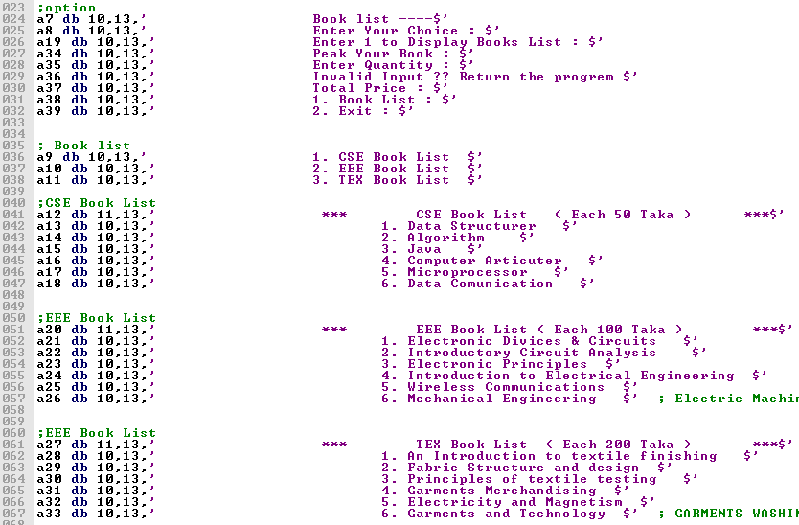

Figure 2.1: This project Interface Some Messages for user .

### Project Source Code

|  |  |  |
| --- | --- | --- |
| **Booklist , Invalid , Exit** | **CSElist: , EEElist , TEXlist** | **Fifty:, Hundred, TwoH.** |
| **Booklist:** | **CSElist:** | **fifty:** |
| mov ah,2 | mov ah,2 | mov bl,5 |
| mov dl,10 int 21h | mov dl,10 int 21h | mov dx,offset a35 |
| mov dl,13 int 21h | mov dl,13 int 21h | mov ah,9 int 21h |
| mov ah,2 | mov ah,2 | mov ah,1 int 21h sub al,48 |
| mov dl,10 int 21h | mov dl,10 int 21h | mul bl |
| mov dl,13 int 21h | mov dl,13 int 21h | aam ; ascii adjust after |
| mov ah,9 | ;CSE Book List start | multiplication aan |
| mov dx,offset a7 | mov ah,9 | mov cx,ax |
| int 21h | mov dx,offset a12 | add ch,48 |
| mov dx,offset a9 | int 21h mov ah,2 | add cl,48 |
| int 21h | mov dl,10 int 21h | mov dx,offset a37 |
| mov dx,offset a10 | mov dl,13 int 21h | mov ah,9 int 21h |
| int 21h | mov ah,9 | mov ah,2 |
| mov dx,offset a11 | mov dx,offset a13 | mov dl,ch int 21h |
| int 21h | int 21h | mov dl,cl int 21h |
| ;Book List Choice | mov dx,offset a14 | mov dl,’0’ int 21h |
| mov dx,offset a8 | int 21h | mov dl,47 int 21h |
| int 21h | mov dx,offset a15 | mov dl,45 int 21h |
| mov ah,1 int 21h | int 21h | ;for exit or main menu |
| mov bh,al | mov dx,offset a16 | mov ah,2 |
| sub bh,48 | int 21h | mov dl,10 int 21h |
| cmp bh,1 je CSElist | mov dx,offset a17 | mov dl,13 int 21h |
| cmp bh,2 je EEElist | int 21h | mov ah,9 |
| cmp bh,3 je TEXlist | mov dx,offset a18 | mov dx,offset a38 |
| jmp Invalid | int 21h | int 21h |
| **Invalid:** mov ah,2 | mov dx,offset a34 | mov ah,9 |
| mov dl,10 int 21h | int 21h | mov dx,offset a39 |
| mov dl,13 int 21h | mov ah,1 int 21h | int 21h |
| mov ah,2 | mov bl,al | mov ah,9 |
| mov dl,10 int 21h | sub bl,48 | mov dx,offset a8 |
| mov dl,13 int 21h | cmp bl,1 je fifty | int 21h |
| mov ah,9 | cmp bl,2 je fifty | mov ah,1 int 21h |
| mov dx,offset a36 | cmp bl,3 je fifty | sub al,48 |
| int 21h | cmp bl,4 je fifty | cmp al,1 |
| jmp Exit | cmp bl,5 je fifty | je BookList |
| **Exit:** mov ah,4ch | cmp bl,6 je fifty | cmp al,2 je Exit |
| int 21h | jmp Invalid | jmp Invalid |

In this code table column number 1 has three produce name is Book-list , Invalid and Exit .

In this code table column number 2 given code for CSE-book-list produce we know that another two book list like EEE and TEX book list produce are same .

In this code table column number 3 given code for Fifty produce we know that another two price produce like Hundred and Two-Hundred produce are same .

**Chapter 3**

**Performance Evaluation**

# Simulation Environment/ Simulation Procedure

To simulate the outcomes of our project, me have set up different experimental setups based on my PC configurations. In this section, we will discuss the specific requirements and environment installation needed for each simulation.

## Moshiur PC

For your simulation, the following experimental setup and environment installation are needed: RAM: 16GB , Storage: 512 GB SSD and 1TB HDD, Processor: Intel Core i5 10th generation.

## Moshiur PC(Trurtle)

For your simulation, the following experimental setup and environment installation are needed: RAM: 8GB , Storage: 250 GB SSD , Processor: Intel Core i3 7th generation.

# Results Analysis/Testing

During the testing phase of the book store application in assembly language, thorough validation was performed on user interactions, book selections, and pricing calculations. The program underwent extensive testing to ensure the accurate display of book lists, proper acceptance of user input, and precise calculation of total prices based on selected books and quantities. Multiple test cases were executed to assess the program’s responsiveness and error-handling capabilities. The results confirmed the application’s reliability in handling diverse scenarios, providing a seamless user experience, and generating accurate financial outcomes. The testing process ensured the assembly language code met all specified requirements and consistently delivered expected results.

## Result_portion_Given Invalid Input

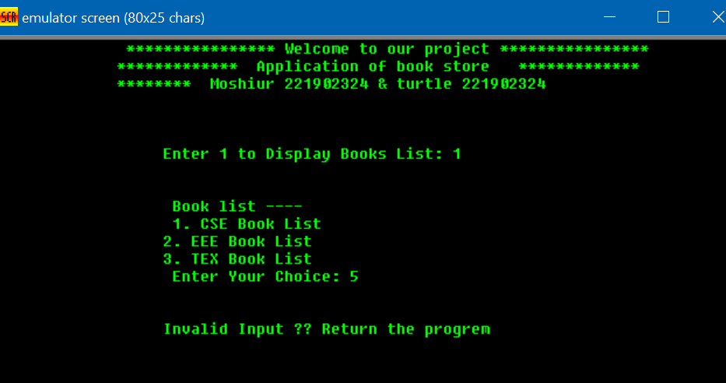

Figure 3.1: Invalid Input Output.

In this Figure 3.1 ,see that user given input 1 so user see the book list.Then user choice 3 types of book but user enter 4 so program say that Invalid Input,Return the program.

## Result_portion_Select CSE Book List

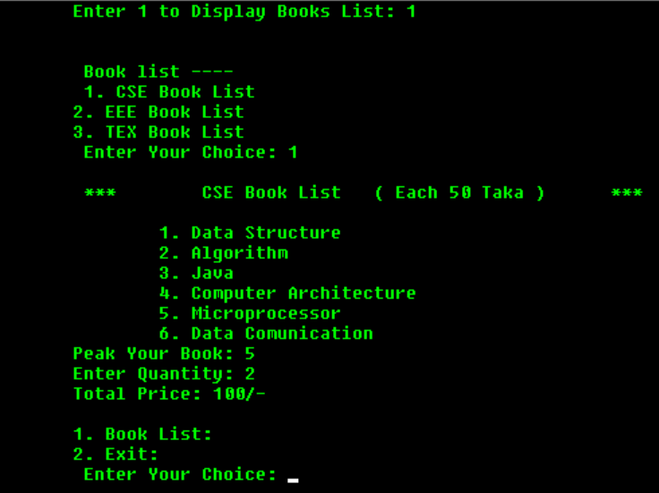

Figure 3.2: CSE Book List Output.

In this Figure 3.2 ,see that user given input 1 so program show the CSE book list then user peak microprocessor book quantity of 2 so total price 100 taka. show that successfully.

## Result_portion_Select EEE Book List

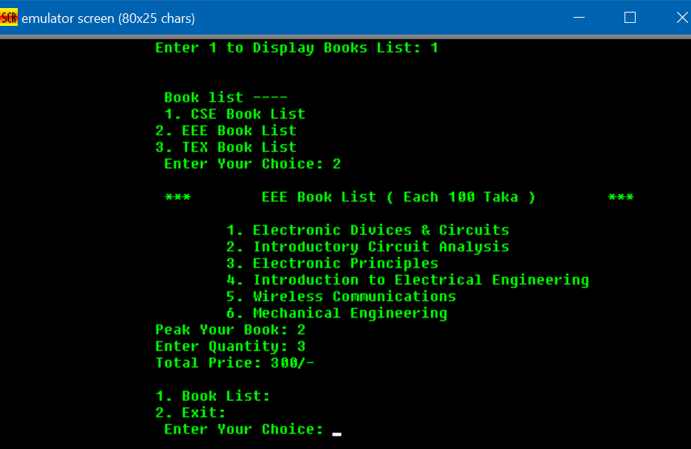

Figure 3.3: EEE Book List Output.

In this Figure 3.3 see user given input 2 so program show the EEE book list then user peak Introductory Circuit Analysis book quantity of 3 so total price 300 taka. show that successfully.

## Result_portion_Select TEX Book List

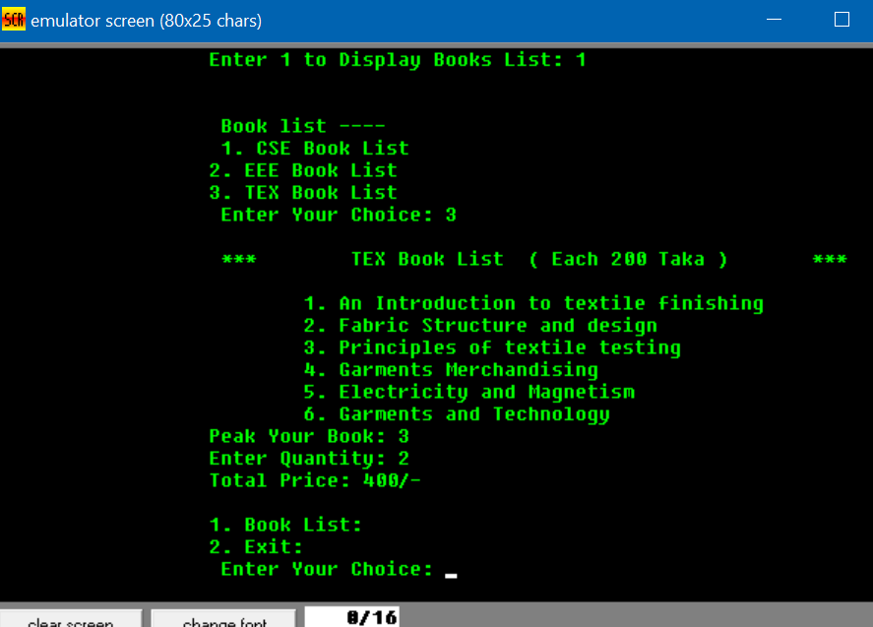

Figure 3.4: TEX Book List Output.

In this Figure 3.4 see user given input 3 so program show the TEX book list then user peak Principles of textile testing book quantity of 2 so total price 400 taka. show that successfully.

# Results Overall Discussion

The results of the book store application in assembly language demonstrate its successful implementation of functional book categorization and pricing features. Users can easily navigate through CSE, EEE, and TEX book lists, selecting and purchasing books with precise pricing. The application effectively manages user inputs, ensuring a seamless experience. However, there is room for improvement in terms of user prompts and error messages. Overall, the appli- cation accomplishes its primary objective by providing a structured platform for book selection and purchase. Future iterations could focus on refining user interactions and expanding the book inventory for a more comprehensive user experience.

**Chapter 4 Conclusion**

# Discussion

The assembly language project for a book store application has successfully demonstrated the implementation of a user-friendly interface for browsing and purchasing books. The project effectively organized the book list and provided intuitive choices for users. Accurate pricing calculations were executed, addressing challenges such as user input validation and branching for book categories. By meeting functional requirements, the project achieved its goal of providing an interactive and functional book store experience through assembly language programming. While potential areas for improvement were identified, the project’s success in delivering a satisfying user experience opens possibilities for future enhancements and optimizations to further enrich the application.

# Limitations

While the book store application in assembly language has been implemented successfully, it does have certain limitations. Currently, advanced features such as user authentication, real- time inventory management, and a secure transaction system are not present in the application. The user interface could also be further enhanced to provide a more visually appealing and user- friendly experience. The absence of error handling for invalid inputs might result in unexpected behavior. Additionally, scalability and extensibility could pose challenges when expanding book categories or incorporating additional functionalities. Addressing these limitations would be beneficial for improving the overall robustness and functionality of the book store application.

# Scope of Future Work

In terms of future work, there are several promising avenues for enhancing the book store ap- plication in assembly language. One potential area for improvement is the introduction of a user authentication system, which can enhance security and provide personalized experiences for users. Real-time inventory updates would also greatly benefit the application by ensuring accurate stock information and preventing overselling. Implementing secure transaction mechanisms can further enhance the application’s security and build trust with customers. Improvements to the user interface, such as a more intuitive design and better error handling mech-

anisms, would contribute to a more user-friendly experience. Expanding the application to include a wider range of book categories and incorporating features like search functionality would broaden its appeal and utility. Continuous updates and improvements will be crucial for maintaining the longevity and relevance of the book store application.

## References

* + - 1. <https://www.tutorialspoint.com/>
      2. <http://www.assemblylanguagetuts.com/>
      3. [www.learn-assembly.com](https://www.learn-assembly.com)
      4. [https:/](https://www.learn-assembly.com)[/www.assemblylanguageprogramming.com/](http://www.assemblylanguageprogramming.com/)
      5. <https://www.assemblyprogramming.net/>
      6. [https://www.x86assembly.net/](http://www.x86assembly.net/)